Aim: Design structure for Currency Conversion

Description:

The provided code defines a simple currency conversion system in Java. The system is designed around an interface named Currency, which outlines the methods necessary for handling currency-related operations. Three concrete classes (USDCurrency, EURCurrency, and INRCurrency) implement this interface, each representing a specific currency (USD, EUR, and INR, respectively). The Main class serves as the entry point for the currency conversion application.

Code:

1. Currency.java

// Currency.java
public interface Currency {
String getCurrencyCode();
String getSymbol();
String format(double amount);
double convert(double amount, Currency targetCurrency);
}

2. USDCurrency.java

// USDCurrency.java

// Concrete implementation of Currency for USD
public class USDCurrency implements Currency {
@Override
public String getCurrencyCode() {
return "USD";
}

@Override
public String getSymbol() {
return "$";
}

@Override
public String format(double amount) {
// Implement formatting rules for USD
return "$" + String.format("%.2f", amount);
}

@Override
public double convert(double amount, Currency targetCurrency) {
if (targetCurrency.getCurrencyCode().equals("USD")) {
return amount; // No conversion needed
} else if (targetCurrency.getCurrencyCode().equals("EUR")) {
return amount * 0.85; // Conversion rate from USD to EUR
} else if (targetCurrency.getCurrencyCode().equals("INR")) {
return amount * 73.50; // Conversion rate from USD to INR
}
return amount;
}
}

3. INRCurrency.java

// INRCurrency.java

// Concrete implementation of Currency for INR
public class INRCurrency implements Currency {
@Override
public String getCurrencyCode() {
return "INR";
}

@Override
public String getSymbol() {
return "₹";
}

@Override
public String format(double amount) {
// Implement formatting rules for INR
return "₹" + String.format("%.2f", amount);
}
}

4. EURCurrency.java

// EURCurrency.java

// Concrete implementation of Currency for EUR
public class EURCurrency implements Currency {
@Override
public String getCurrencyCode() {
return "EUR";
}

@Override
public String getSymbol() {
return "€";
}

@Override
public String format(double amount) {
// Implement formatting rules for EUR
return "€" + String.format("%.2f", amount);
}
}

5. Main
import java.util.Scanner;

public class Main {
public static void main(String[] args) {
Scanner scanner = new Scanner(System.in);

System.out.print("Enter the amount: ");
double amount = scanner.nextDouble();

System.out.print("Choose base currency (USD, EUR, INR): ");
String baseCurrencyCode = scanner.next().toUpperCase();

System.out.print("Choose target currency (USD, EUR, INR): ");
String targetCurrencyCode = scanner.next().toUpperCase();

Currency baseCurrency;
Currency targetCurrency;

switch (baseCurrencyCode) {
case "USD":
baseCurrency = new USDCurrency();
break;
case "EUR":
baseCurrency = new EURCurrency();
break;
case "INR":
baseCurrency = new INRCurrency();
break;
default:
System.out.println("Invalid base currency code. Using USD as default.");
baseCurrency = new USDCurrency();
}

switch (targetCurrencyCode) {
case "USD":
targetCurrency = new USDCurrency();
break;
case "EUR":
targetCurrency = new EURCurrency();
break;
case "INR":
targetCurrency = new INRCurrency();
break;
default:
System.out.println("Invalid target currency code. Using USD as default.");
targetCurrency = new USDCurrency();
}

System.out.println("Conversion from " + baseCurrencyCode + " to " + targetCurrencyCode + ": "
+ targetCurrency.format(baseCurrency.convert(amount, targetCurrency)));
}
}

Output:
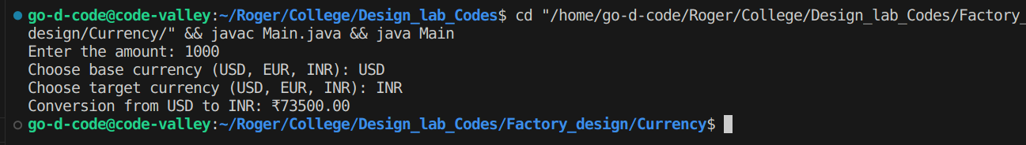
Class Diagram:

